EXP 9 : SIMULATION AND ANALYSIS OF UNIFORM AND NON- UNIFORM QUANTIZATION USING MATLAB

SOFTWARE USED : MATLAB SOFTWARE

CODE:
clc; clear; close all

t=0:0.001:1;
x=sin(2*pi*5*t);
L=8; xmax=1;

% Uniform quantization
q=2*xmax/L;
xu=q*round(x/q);

% Non-uniform quantization (mu-law)
mu=255;
y=sign(x).*log(1+mu*abs(x))/log(1+mu);
yq=q*round(y/q);
xn=sign(yq).*((1+mu).^abs(yq)-1)/mu;

subplot(3,1,1),plot(t,x),title('Original Signal'),grid on
subplot(3,1,2),plot(t,xu),title('Uniform Quantization'),grid on
subplot(3,1,3),plot(t,xn),title('Non-Uniform Quantization'),grid on

fprintf('Uniform MSE = %.4f\n',mean((x-xu).^2));
fprintf('Non-uniform MSE = %.4f\n',mean((x-xn).^2));

MODEL GRAPH :
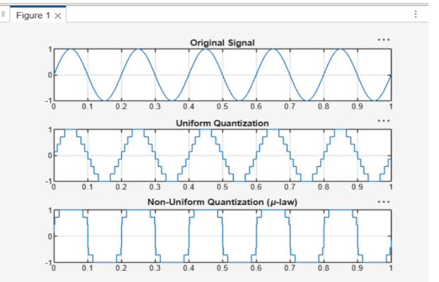

RESULT :
